CHART: WCIV, CHAPTER 21 – ABSOLUTE MONARCHS OF EUROPE
Directions: Use the section summaries to fill in the chart. Make sure you use and include descriptions of each of the items in the word bank on the back.

 | Names of Monarchs | Actions of Absolute Monarchs | Conflicts of Absolute Monarchs
Spain

France
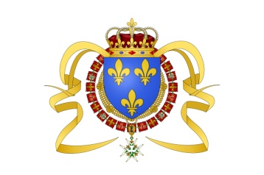

England
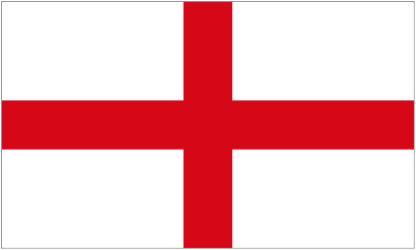

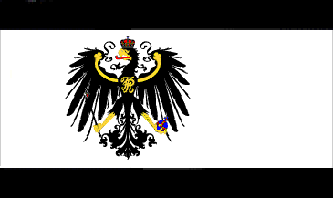  Austria & Prussia  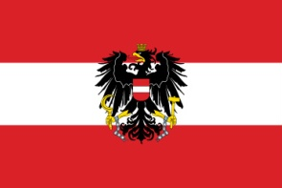 | Austria  Prussia
Russia
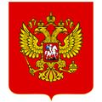

Make sure the following events are included in the proper place in your chart. They are NOT in order.
Names of Absolute Monarch | Actions of Absolute Monarchs | Conflicts of Absolute Monarchs
- Peter the Great  - Catherine the Great | - Built palace of Versailles | - Thirty Year War: brutal wars over power struggles in the Holy Roman Empire, ending with The Peace of Westphalia, increasing the power of German princes
- Frederick William I  - Frederick II | - Built St. Petersburg, a symbol of modern Russia | - War against Sweden to win territory on Baltic Sea
- Philip II | - Expanded royal government, appointed intendants to collect taxes, & recruited soldiers | - War of Austrian Succession: conflict between Austria and Prussia over land
- Louis XIII | - Created new bureaucracy (government administration) and emphasis on military values | - English Civil War: Puritan Oliver Cromwell and Parliament against the king.
- Maria Theresa | - Expanded Spain’s Power | - Costly wars to extend borders caused a decrease in prosperity
- James I  - Charles I  - Charles II  - James II | - Used military education to make Prussia a leading power in Europe | - Sent an armada against England
 | - Appointed Jean Baptiste Colbert to expand commerce and trade | - Defeated the Ottomans and won the warm-water port on the Black Sea
 | - Poland is partitioned between three states (Russia, Austria, Prussia) | - Glorious Revolution: Parliaments offers crown to William and Mary, establishing a limited monarch and the English bill of Rights
 | - Stuart kings clashed with Parliament over money & religion
 | - Began westernization—adoption of European ideas, culture, and technology
 | - Strengthened the Catholic Church
 | - Codified laws and established public education for boys and girls
 | - Preserved empire, strengthened Hapsburg power by reorganizing government and improving tax collection

