STUDENT TEACHERS PROJECT: WCIVHONORS, CHAPTER 14 – THE FORMATION OF WESTERN EUROPE

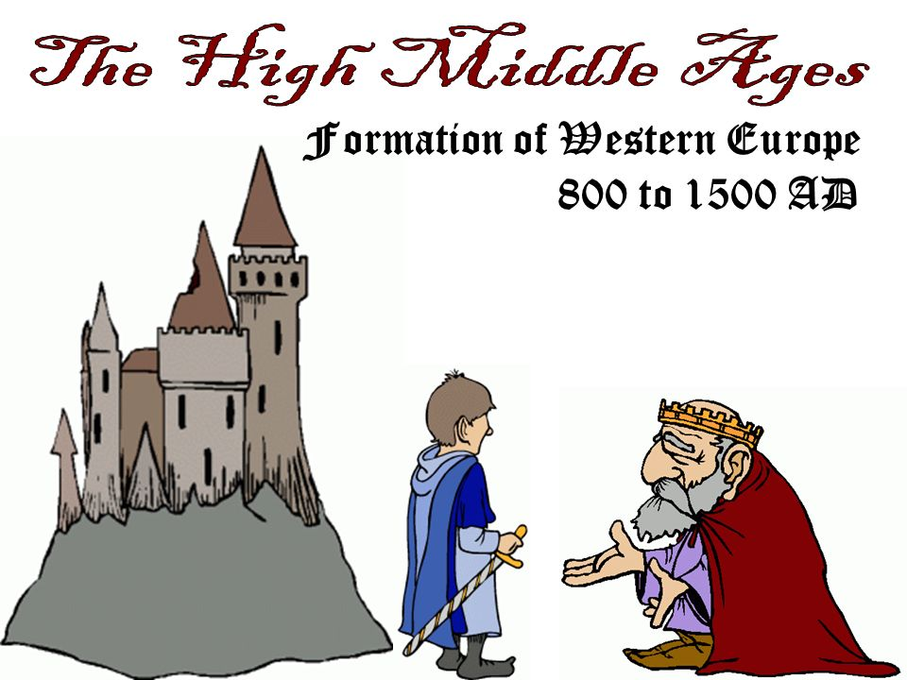

For this project, you will be working in a group of assigned students to present the information in Chapter 14 – The Formation of Western Europe. In your assigned group, you will be responsible for breaking down your section as a group and finding a way to present the information to the class. You can present the information in any way that your group decides. Here are a few suggestions for ways that will effectively portray your sections:

-PowerPoint
-Create and act out a skit
-Make a TV or radio commercial
-Create an instructional video
-Act out a news show
-Hold a debate
-Create a handout and have a discussion
-Design an activity to involve classmates
-Make a timeline and discuss events
-Any other idea you can think of

This assignment will be worth 40 Points. The rubric is on the back of this page.

Projects will be presented on: ________________________________________

Effective use of class time | /10
Information accurately and effectively portrayed to class | /20
Group effort – working collaboratively | /10
Total Points | /40

Section 1
Trevon
Miriam
Tabuno
Raven
Nicole

Section 2
Robbyn
LaCrisha
Diamond
Camren
Melah
Kaelyn

Section 3
Marsell
Savion
Ola
Brandon
Kevin
Jalen Lewis

Section 4
Germy
Khafre
DiVine
JT
Precious
Shaniya

